**DIAGRAMS**

**1. Block Diagram**

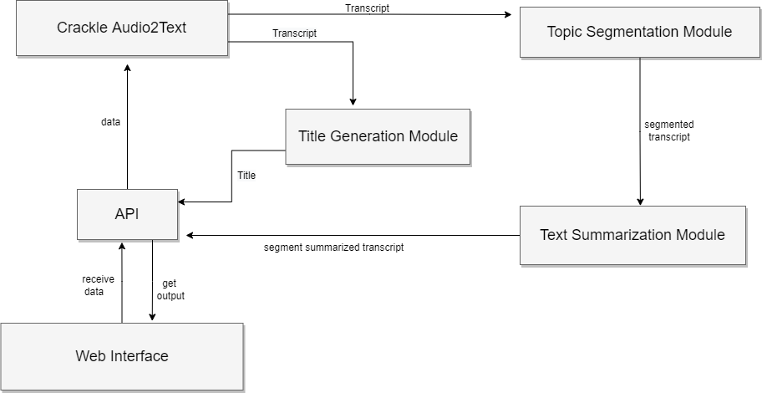 **Fig. 1.** Block Diagram

**2. Data Flow Diagrams**

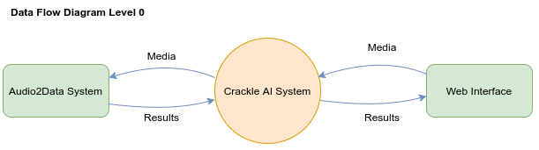

**Fig 2.1.** Data Flow Diagram Level 0

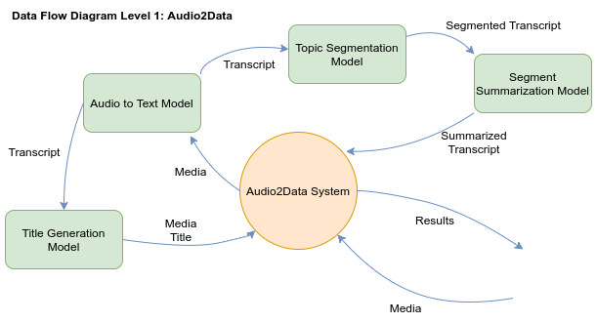

**Fig 2.2.** Data Flow Diagram Level 1

**3. Class Diagram**

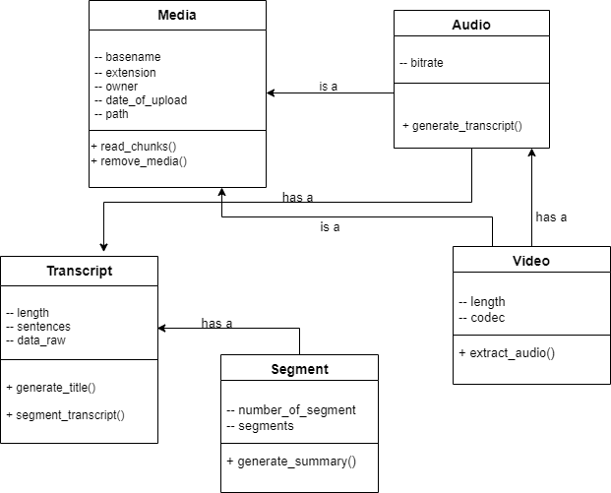 **Fig. 3.** Class Diagram

**4. Component Diagram**

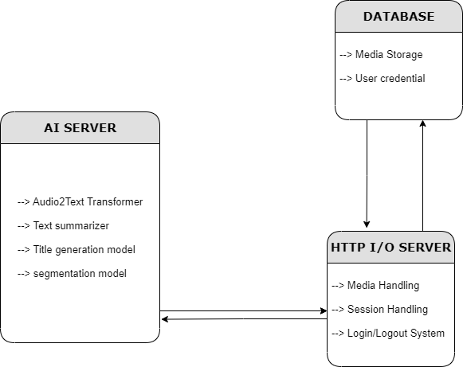 **Fig. 4.** Component Diagram

**5. Use Case Diagrams**

**5.1. Login**

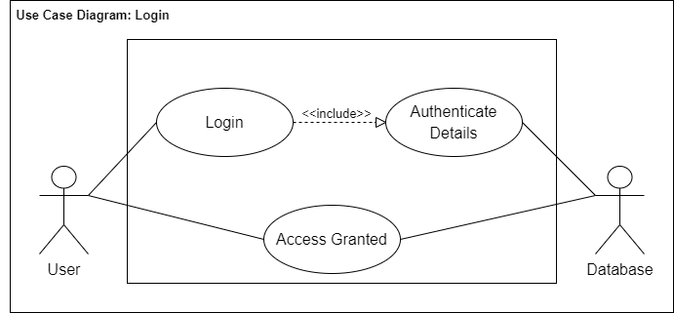 **Fig. 5.1.** Use Case Diagram – Login

|  |  |
| --- | --- |
| 1. Use Case ID | 1 |
| 1. Use Case Title | Login |
| 1. Actors | User, Database |
| 1. Purpose: To allow the user to log in to their account | |
| 1. Description: Authenticate user details to grant them access to database | |
| 1. Pre-conditions: 2. Internet Access 3. Have an existing account in the database | |
| 1. Task Sequence: 2. User opens the website 3. User enters details/credentials 4. User clicks on the login button 5. User is logged in | |
| 1. Alternate Flow: No alternate scenario | |
| 1. Post-conditions: 2. User is logged in to their account | |
| Modification History: 10-June-2022 | |
| Author: Harshit Vishwakarma, Vernica Beohar, Shruty, Akshat Sharma | |

**5.2. Sign Up**

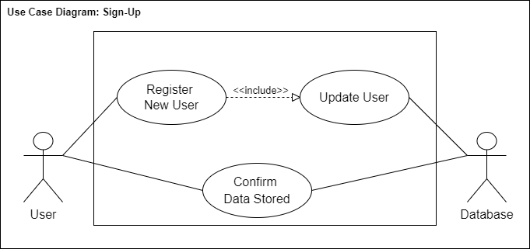 **Fig. 5.2.** Use Case Diagram – Sign Up

|  |  |
| --- | --- |
| 1. Use Case ID | 2 |
| 1. Use Case Title | Sign Up |
| 1. Actors | User, Database |
| 1. Purpose: To allow the user to sign up and create an account | |
| 1. Description: Update user details and store them in the database | |
| 1. Pre-conditions: 2. Internet Access | |
| 1. Task Sequence: 2. User opens the website 3. User enters details/credentials 4. User clicks on the sign-up button 5. User is registered in the database | |
| 1. Alternate Flow: No alternate scenario | |
| 1. Post-conditions: 2. User’s account is created and stored in the database | |
| Modification History: 10-June-2022 | |
| Author: Harshit Vishwakarma, Vernica Beohar, Shruty, Akshat Sharma | |

**5.3. Summary Service**

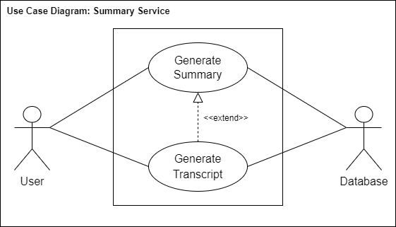 **Fig. 5.3.** Use Case Diagram – Summary Service

|  |  |
| --- | --- |
| 1. Use Case ID | 3 |
| 1. Use Case Title | Summary Service |
| 1. Actors | User, Database |
| 1. Purpose: To provide an apt summarized title for the video uploaded | |
| 1. Description: Generate audio transcript and generate its summary to create title | |
| 1. Pre-conditions: 2. Internet Access 3. Have an existing account in the database | |
| 1. Task Sequence: 2. User opens the website 3. User enters details/credentials 4. User uploads a video 5. A summary is generated for the video transcript | |
| 1. Alternate Flow: No alternate scenario | |
| 1. Post-conditions: 2. An apt title for the video is shown to the user | |
| Modification History: 10-June-2022 | |
| Author: Harshit Vishwakarma, Vernica Beohar, Shruty, Akshat Sharma | |

**6. Activity Diagrams**

**6.1. Login**

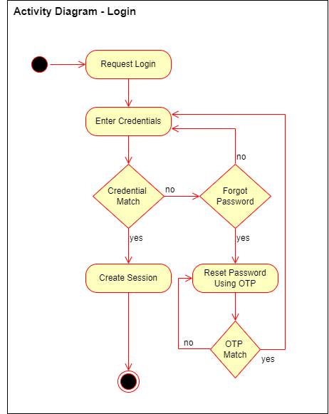 **Fig. 6.1.** Activity Diagram – Login

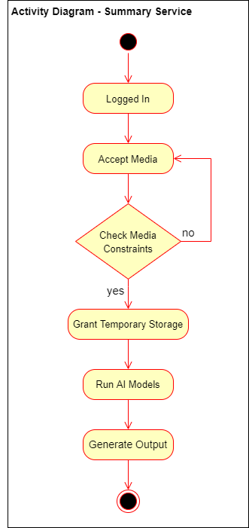 **6.2. Sign Up 6.3. Summary Service**

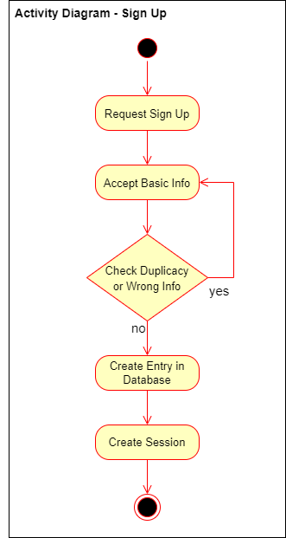   
 **Fig. 6.2.** Activity Diagram – Sign Up

**Fig. 6.3.** Activity Diagram – Summary Service